 | MATHEMATICS: SPECIALIST UNITS 1 & 2  INVESTIGATION 4  PART A

MATHEMATICAL INDUCTION

Date of Validation:

You will have time at home to work on Part A. I will check your take-home part and award 0, 1 or 2 marks depending on your effort on Friday 9th September and hand you fully worked solutions. Your validation will be on Tuesday 12th September. You WILL NOT be permitted to use Part A in Part B - the validation.

Mathematical Induction is a rigorous method of mathematical proof that adopts a consistent algebraic structure. The key part of the argument requires similar skills to the proving of trigonometric identities.

The principle of Mathematical Induction states:

“If a set of positive integers:

(a) contains the positive integer 1, and

(b) can be proved to contain the positive integer k + 1 whenever it contains all positive integers 1, 2, 3, ..., k,

then the set contains all positive integers.”

The principle of Mathematical Induction is used to prove many results in algebra and calculus.

EXAMPLE 1
Prove: 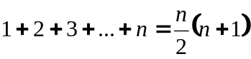 for all positive integers n.
Step 1: Verify the statement is true when n = 1.

L.H.S. = 1
R.H.S. = 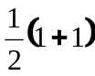
= 1
⇒ Statement is true for n = 1.

Step 2: Assume the statement is true for n = k.
That is, 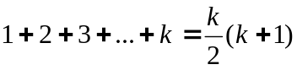

Step 3: Prove the statement is true for n = k + 1

That is, prove 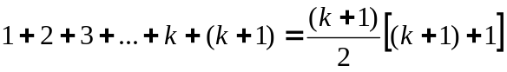
L.H.S. =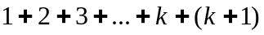
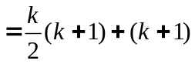 (From step 2)
=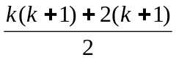
=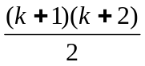
=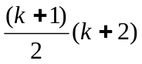
=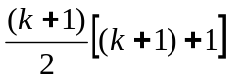

= R.H.S.

⇒ The statement is true for n = k + 1 if it is true for n = k.

Step 4: As the statement is true for n = 1, it must be true for n = 2.
As the statement is true for n = 2, it must be true for n = 3 and so on.
Hence, 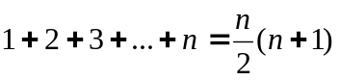 is true for all positive integers n.
EXAMPLE 2

Prove: 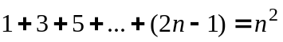 for all positive integer n.

Step 1: Verify the statement is true for n = 1.

L.H.S. = 2 × 1 − 1

= 1

R.H.S. = 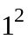

= 1

⇒ Statement is true for n = 1

Step 2: Assume the statement is true for n = k.

That is, 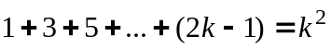

Step 3: Prove the statement is true for n = k + 1.

That is, prove 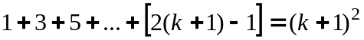

L.H.S. =
= 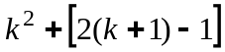 (from step 2)
=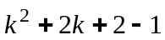
=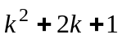
=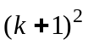
= R.H.S.

⇒ The statement is true for n = k + 1 if it true for n = k.

Step 4: As the statement is true for n = 1 it must be true for n = 2.
As the statement is true for n = 2 it must be true for n = 3 and so on.

Hence, is true for all positive integers n.

EXAMPLE 3

Prove: 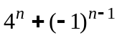 is divisible by 5 for all positive integers.

Step 1: Verify the statement is true when n = 1.

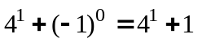
= 5
Divisible by 5.
⇒ Statement is true when n = 1.

Step 2: Assume true when n = k.
That is, 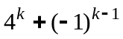 is divisible by 5.

Step 3: Prove the statement is true for n = k + 1
That is, prove that 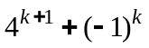 is divisible by 5.

=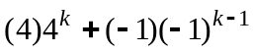
=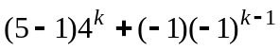
=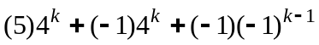
=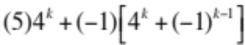
Clearly 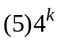 is divisible by 5 and
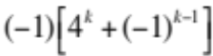 is divisible by 5 because the factor 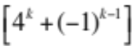 is divisible by 5.
Hence is divisible by 5
⇒ The statement is true for n = k + 1 if it is true for n = k.

Step 4: As the statement is true for n = 1 it must be true for n = 2.
As the statement is true for n = 2 it must be true for n = 3 and so on.

Hence, is divisible by 5 for all positive integers.
QUESTIONS TO ANSWER

Use the principle of Mathematical Induction to prove the following results are true for all positive integers n:

1. 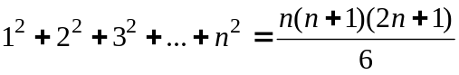

2. 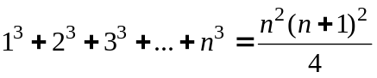

3. 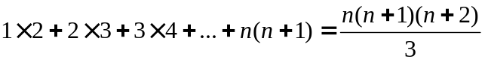

4. 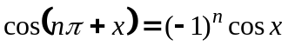

5. 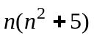 is divisible by 6.

6. Prove for all natural numbers 